Introduction

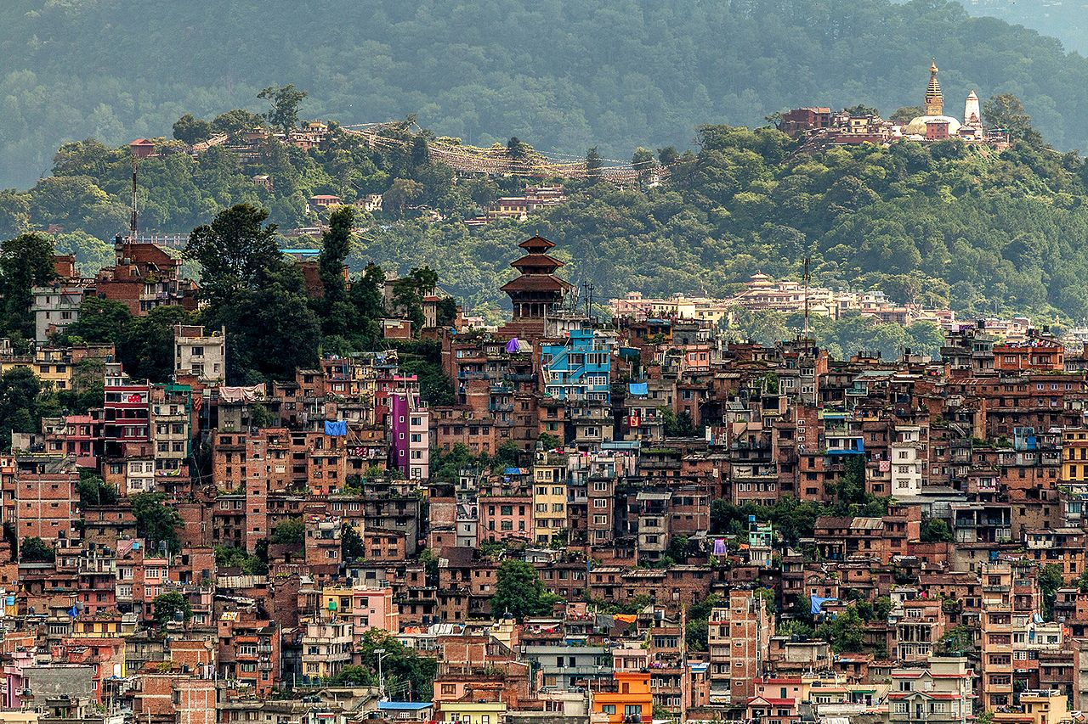

Kirtipur (Nepali: कीर्तिपुर; Nepal Bhasa: किपू Kipoo) is a Municipality and an ancient city of Nepal. The Newars are the natives of Kipoo (Kirtipur) that is believed to be derived from Kirati King Yalamber. It is located in the Kathmandu Valley 5 km south-west of the city of Kathmandu. It is one of the five dense municipalities in the valley, the others being Kathmandu, Lalitpur, Bhaktapur and Madhyapur Thimi. It is one of the most famous and religious places to visit[clarification needed]. Many people visit this place not only for its natural environment but also to visit temples. The city was listed as a UNESCO tentative site in 2008.

History

Kirtipur's history dates from 1099 A.D. It was part of the territory of Lalitpur at the time of the invasion of the Kathmandu Valley by the Gorkhali king [Prithvi Narayan Shah](https://en.wikipedia.org/wiki/Prithvi_Narayan_Shah) in the 18th century.

In 1767, Kirtipur was annexed to the Gorkhali kingdom by Prithvi Narayan Shah following the [Battle of Kirtipur](https://en.wikipedia.org/wiki/Battle_of_Kirtipur). He conquered the town on his third attempt, after entering it by trickery. After this, he cut off the noses of the people (both male and female) over 13 years of age in the city.[[9]](https://en.wikipedia.org/wiki/Kirtipur#cite_note-9)[[10]](https://en.wikipedia.org/wiki/Kirtipur#cite_note-10)

This was the site of an inspirational peaceful demonstration of the people in the 2006 mass uprising that overthrew the powers of the king. It is considered to be an anti-monarchy city due to its bitter history against the Shah dynasty whose modern founder conquered the city insultingly, which was followed by negligence of the administration and development by subsequent rulers.

Places of interest

[Bagh Bhairab Temple](https://en.wikipedia.org/wiki/Bagh_Bhairab_Temple) is one of the most popular temples dedicated to the god [Bhairab](https://en.wikipedia.org/wiki/Bhairava" \o "Bhairava) in the form of an angry tiger. This god is regarded as the guardian of Kirtipur and the locals call it Ajudeu, a grandfather god. Bhairab, the most terrifying and awful form of Shiva, is the destroyer on one hand and the guardian on the other. Ceremonial rituals in relation to the important events of life such as rice-feeding, puberty, marriage and even the construction of houses cannot be done without propitiating this deity in most of the towns and cities of Nepal.

Bagh Bhairab is mainly worshiped by the Munsi Newars (Man Singh Pradhan). Each of the male family members, on a yearly basis, are supposed to take the chest of Bagh Bhairab turn by turn and keep it in a secret room and worship it twice a day. It is believed that any wrong method applying for worship might curse the individual. Denial for taking the chest home accounts for a fine equivalent to US$2000.

The present three storeyed temple of Bagh Bhairab, probably built in the 16th century, stands in the brick-paved rectangular courtyard with rest houses around it. Some small shrines and stone idols are spread over the courtyard. The main gate is at the southern side of the courtyard. There are two other gates on the eastern and western sides. The two roofs of the temple are made of tiles while the third is covered with gilt copper. Wooden posts with the carving of Hindu gods and goddesses adorn the temple in addition to supporting its roof. They have been installed in between windows of the second storey, and the names of the carved deities have been finely cut out below them on the pedestals.

There are eighteen pinnacles: one on the first roof, six on the middle and eleven on the top. Beneath the eaves of the first roof there are very old but faded murals depicting the stories of Ramayan. Maha Bharat and the various manifestations of Durga, the mighty goddess. These paintings are frescoes in red with white plaster background. At the right side of the main gate of the temple there is Hifa Dyo, the god of blood sacrifice is allowed directly to Bagh Bhairab, all animal offerings here are made to this deity just like the animal sacrifices are made to Kumari, a stone idol, placed at the second gate in the left side of Chandeswori in Banepa and to the Chhetrapal which is at the very beginning of the final series of the steps to the temple of Khadga Jogini in Sankhu.

There are two torans over Hifa Dyo. They bear very fine cuttings of Asta-Matriks, Asta-Bhairabs and other gods and goddesses. In the western wall of the temple there is a hollow space regarded by the local people as Nasa Dyo, the god of music and dance. Bagh Bhairab made of clay has been enshrined in the left side corner in the temple. The three glass-eyed tiger-god is tongue-less and tooth-less but covered with silver and copper plates and heavily ornamented. This deity as mentioned in the stone inscriptions has been called Bagheswor (the tiger god), Bhimsen Bhattarak(Bhimsen, the governing deity), Gudei Sthanadhipati (the lord in the form of tiger) and Ajudyo(the ancestral god).

The local people regard this deity as the embodiment of prudence, knowledge, productivity and strength to resist all evils. Hence, the auspicious ceremonies such as weddings, Bratabandha (rite of passage for adolescent boys), Pasni (rice-feeding) and other ritual performances in Kirtipur are done only after a ceremonial worship to this deity.

**Chilancho Stupa**

A Buddhist shrine is situated on the southern hill. Chilancho Vihar (monastery) is situated on the eastern side of Kirtipur, Nepal. It was made in the medieval period. An inscription of Nepal Samvat 635 (Licchavi Period) is found in this Chaitya. Therefore, it is one of the most important historical stupas of this region. In [Nepal Bhasa](https://en.wikipedia.org/wiki/Nepal_bhasa), the word ***Chilan*** means **immortal** and the word ***Cho*** means **Hill**. Therefore, its literal meaning is the immortal god situated on the hill. The stupa is about  9.0-10.5 high on a quadrangular base. On all four sides, there are small chaityas. The dome is plastered white.

**Uma Maheshwar**

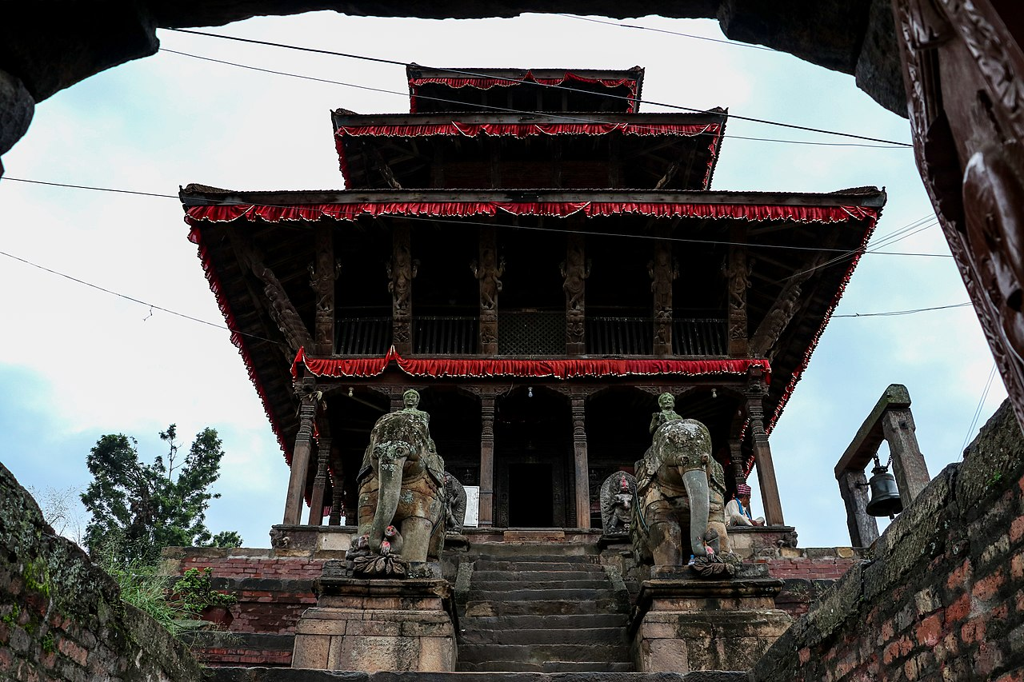

Uma Maheshwar temple (locally, Kwacho Dega) is one of the important heritage sites of Kirtipur. This pagoda-style three-storied temple is situated at the highest point (1414 m) of Kirtipur. Since this temple is at the top of the hill, one can enjoy picturesque view of the Kathmandu valley and mountains like Langtang, Dorge Lakkpa, Chobhu Bhamure, and Gaurishankar.

The temple was constructed in 1655 A.D. by Rautra Vishwanath Babu, a son of king Sidhhi Narsinga Malla. It was destroyed in an earthquake in 1832 A.D. After remaining dilapidated for about a century, it was restored in 1933 A.D. after it was again destroyed by an earthquake. Local people and government made a herculean effort to renovate it into the current state. The restoration process was completed only in 1982 A.D. In 2008 some work was done to preserve the arts of temple.

There is an artistic stone gate at the entrance. On each side of the stone staircase leading to the temple is a stone elephant, with sculptures of Bhimsen and Kuber as protectors of the temple. The main deities in this temple are standing Lord Shiva and Parvati. There are other images of deities like Sarasvati and Mahismardini on false doors around temple.

The wooden doors, pillars, and beams are crafted with artistic figures of different gods and goddess such as Astamatrika and Asta Bhairav. Similarly, erotic figures are also carved in wooden beams. According to archeologists, these figures on beams have tantric values.

The bell on the northern side of temple was cast in 1895 by Gillett & Johnston Founders, Corydon. It was one of the four quarter bells of Ghantaghar of the central Kathmandu and was reallocated to this temple after the Ghantaghar was destroyed by the earthquake in 1933.

**Nagar Mandap Shri Kirti Bihar**

A Theravada Buddhist monastery built in traditional Thai architectural style, is situated near the entrance to the city.

Media

To promote local culture Kirtipur has one FM radio station, Radio Newa F.M. - 106.6 MHz, a [community radio](https://en.wikipedia.org/wiki/Community_radio) station. There are several weekly newspapers published from Kirtipur. They are *Shahid* weekly, *Kirtipur Darpan*, *Kirtipur Sandesh*, and *Jwajalapa* weekly. There is a local television station, Kirtipur Channel, and some more local channels. To Promote local culture, heritages, events Kirtipur Area has popular Facebook page named [Panga, Kirtipur](https://www.pangakirtipur.com.np/) where people can get all the updates of events happened before and happening .

Kathmandu durbar square introduction

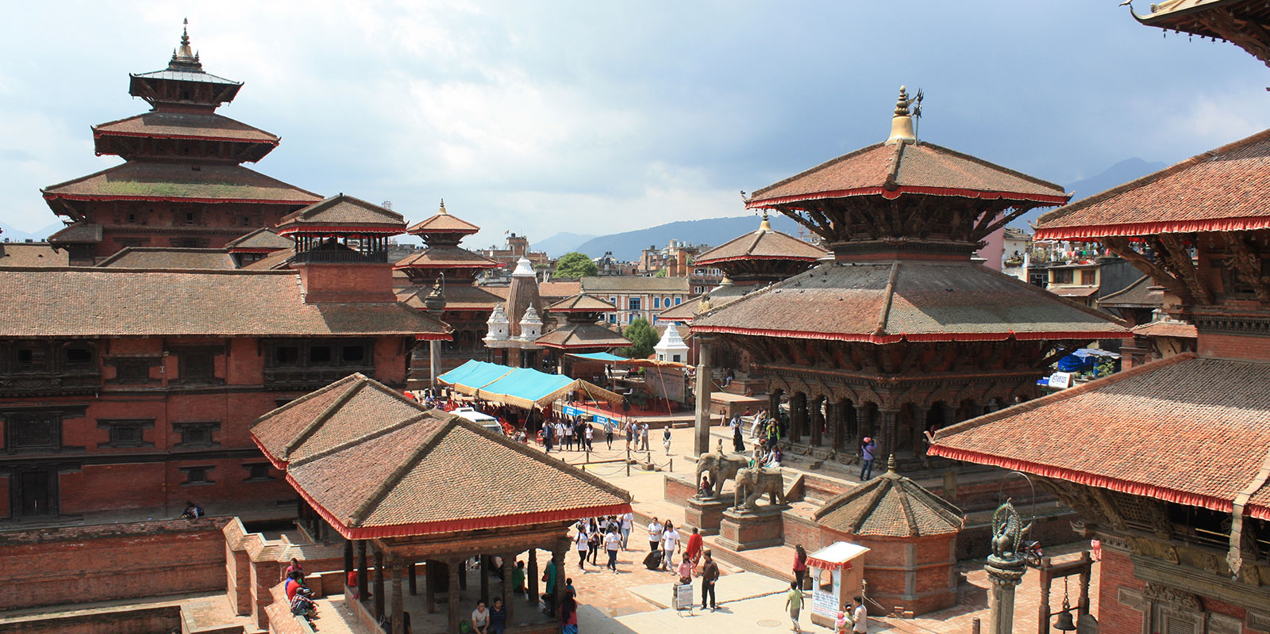

**Kathmandu Durbar Square** ([Nepal Bhasa](https://en.wikipedia.org/wiki/Nepal_Bhasa): येँ लायकु/𑐥𑐾𑑄 𑐮𑐵𑐫𑐎𑐹, [Nepali](https://en.wikipedia.org/wiki/Nepali_language): हनुमानढोका दरबार/ *Basantapur Durbar Kshetra*) is a historically and culturally significant site in [Kathmandu](https://en.wikipedia.org/wiki/Kathmandu), [Nepal](https://en.wikipedia.org/wiki/Nepal). It is one of the three [Durbar (royal palace) Squares](https://en.wikipedia.org/wiki/Durbar_Square) in the [Kathmandu Valley](https://en.wikipedia.org/wiki/Kathmandu_Valley) in Nepal that are [UNESCO World Heritage Sites](https://en.wikipedia.org/wiki/World_Heritage_Site).

Although the construction of the square began in the 3rd century, the major structures within it were added in later periods. The outer complex consists of a number of 16th-century temples built during the reign of [Malla](https://en.wikipedia.org/wiki/Malla_(Nepal)) kings. These buildings are adorned with meticulously carved facades characteristic to [Newar architecture](https://en.wikipedia.org/wiki/Newar_architecture). The central square is surrounded by palace complexes built during the Malla and [Shah](https://en.wikipedia.org/wiki/Shah_dynasty) periods. The most well-known among them is the [Nautalle Durbar](https://en.wikipedia.org/wiki/Nautalle_Durbar" \o "Nautalle Durbar), a nine-story palace built by [Prithvi Narayan Shah](https://en.wikipedia.org/wiki/Prithvi_Narayan_Shah) to commemorate the [Unification of Nepal](https://en.wikipedia.org/wiki/Unification_of_Nepal).

A three-story temple called Kumari Chouk or Kumari Bahal is located at the southern edge of the Durbar square. This Malla-era temple is used as the resident of the *Kumari*, a young girl worshipped as a living embodiment of the Hindu Goddess [Durga](https://en.wikipedia.org/wiki/Durga).

History

Kathmandu Durbar Square is where the Malla and Shah kings were once crowned and from where they ruled the country from 1768 (*when Kathmandu became the capital city of Nepal*) until 1896 (*when the royal residence moved to the Narayanhiti Palace*). The name of Kathmandu comes from Kasthamandap, a 7th century building located in the Durbar Square (*unfortunately, Kasthamandap was totally destroyed by the April 2015 Earthquake*). It is believed that the construction of the Durbar Square dates back to the Licchavi era, around the 3rd century. But the major temples, buildings and monuments were built by the Malla kings between the 13th and 18th centuries.

The coronations of King Birendra Bir Bikram Shah in 1975 and King Gyanendra Bir Bikram Shah in 2001 were held in Kathmandu Durbar Square, more precisely in Nasal Chowk.

Today, Kathmandu Durbar Square is still the place where are held many festivals, ceremonies and religious rituals of important significance.

Places of interest

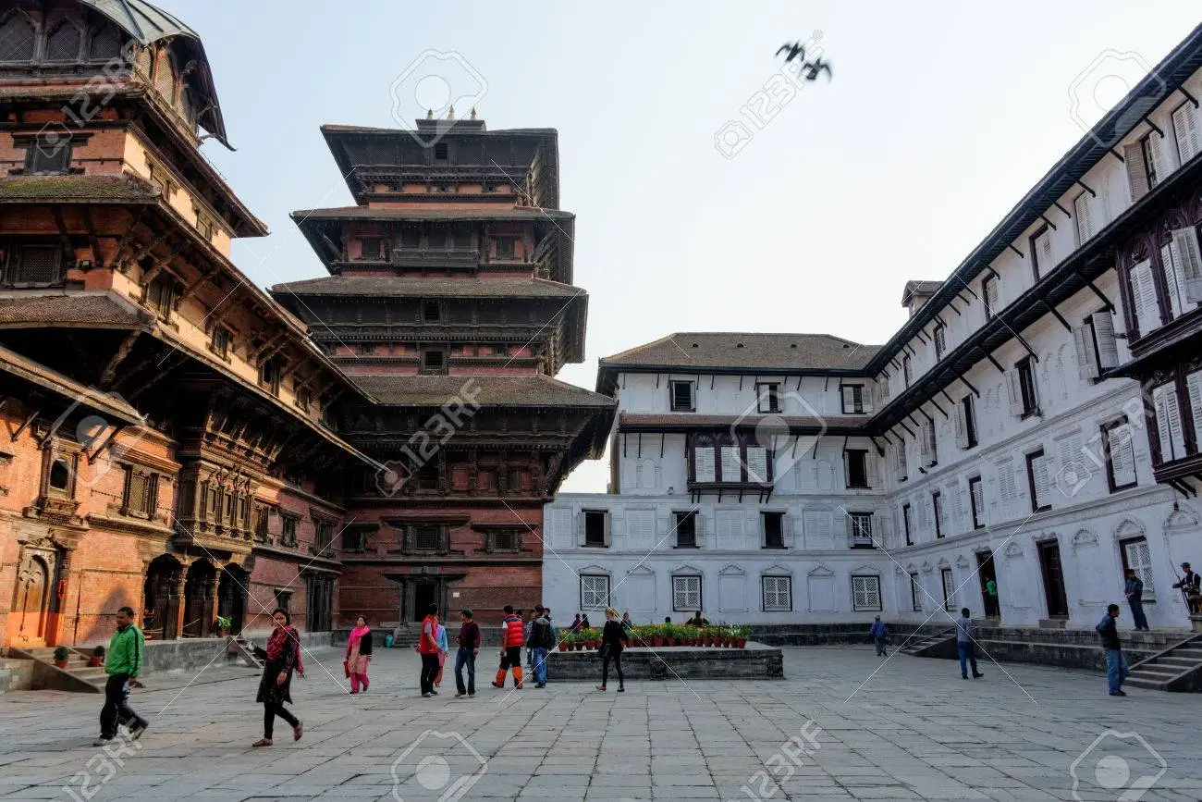

**Hanuman Dhoka** ([Nepali](https://en.wikipedia.org/wiki/Nepali_language): हनुमान ढोका) is a complex of structures with the Royal Palace of the [Malla](https://en.wikipedia.org/wiki/Malla_(Nepal)) kings and also of the [Shah dynasty](https://en.wikipedia.org/wiki/Shah_dynasty) in the [Durbar Square](https://en.wikipedia.org/wiki/Basantapur_Durbar_Square) of central [Kathmandu](https://en.wikipedia.org/wiki/Kathmandu), [Nepal](https://en.wikipedia.org/wiki/Nepal). It is spread over five acres. The Hanuman Dhoka Palace (Hanuman Dhoka Darbar in Nepali) gets its name from the stone image of [Hanuman](https://en.wikipedia.org/wiki/Hanuman), the Hindu deity, that sits near the main entryway. 'Dhoka' means door or gate in [Nepali](https://en.wikipedia.org/wiki/Nepali_language).[[1]](https://en.wikipedia.org/wiki/Hanuman_Dhoka#cite_note-Hanuman_Dhoka-1) The buildings were severely damaged in the [2015 earthquake](https://en.wikipedia.org/wiki/April_2015_Nepal_earthquake).

History

The eastern *wing* with ten courtyards is the oldest part dated to the mid 16th century. It was expanded by King [Pratap Malla](https://en.wikipedia.org/wiki/Pratap_Malla) in the 17th century with many temples. Sundari Chok and Mohan Chok in the north part of the palace are both closed. In 1768, in the southeast part of the palace, four lookout towers were added by [Prithvi Narayan Shah](https://en.wikipedia.org/wiki/Prithvi_Narayan_Shah). The royal family lived in this palace till 1886. They after shifted to [Narayanhiti Palace](https://en.wikipedia.org/wiki/Narayanhiti_Palace" \o "Narayanhiti Palace). The stone inscription outside is in fifteen languages. The stone is a [jaladroni](https://en.wikipedia.org/wiki/Tutedhara" \l "Royal_inscriptions" \o "Tutedhara) (drinking fountain) and legend states that for someone who understands all 15 languages, milk instead of water would spring from it.

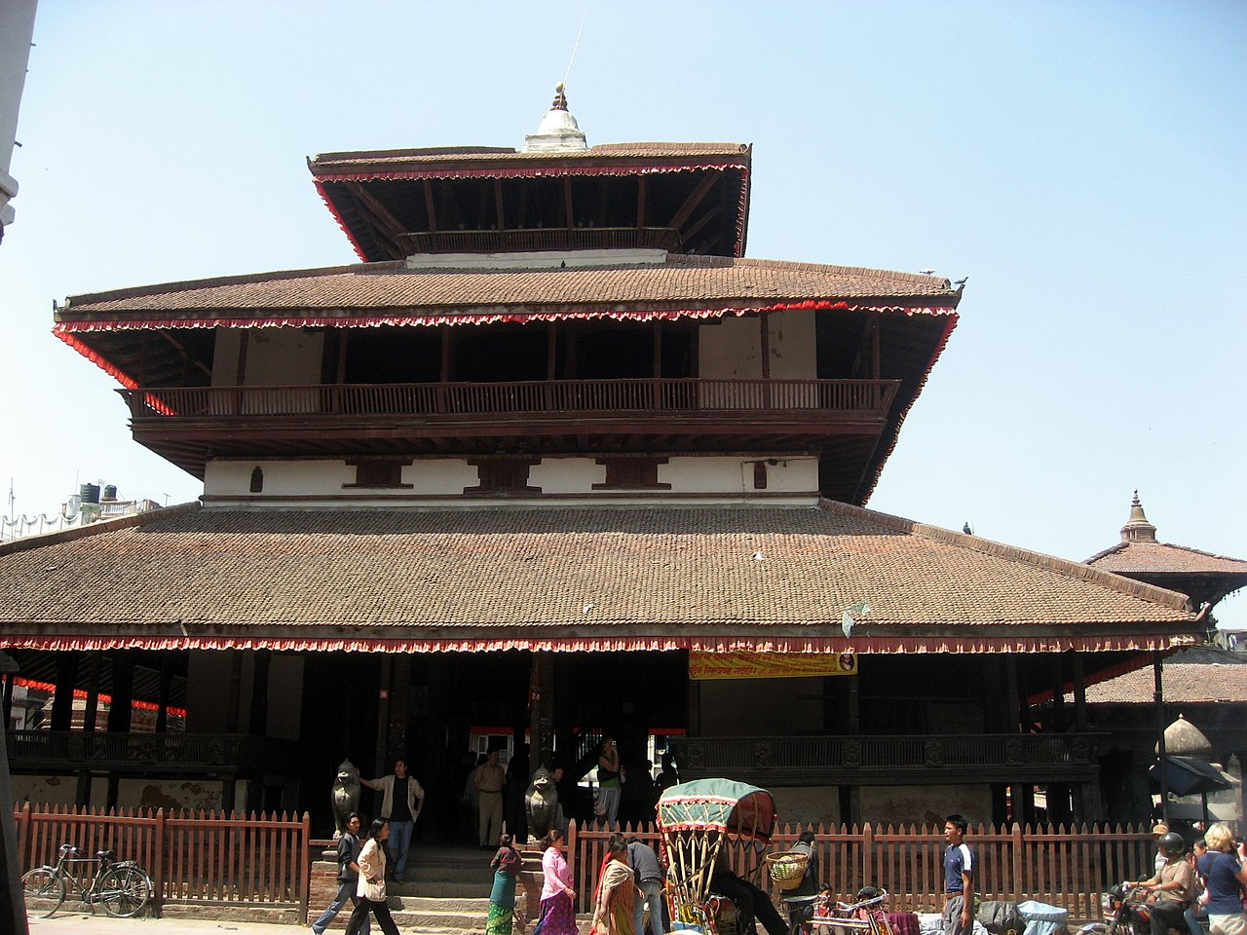

**Kasthamandap** ([Sanskrit](https://en.wikipedia.org/wiki/Sanskrit): काष्ठमण्डप, [Nepal Bhasa](https://en.wikipedia.org/wiki/Nepal_Bhasa):मरु सत: *Maru Satta:*; literally "Wood-Covered Shelter") was a three-storied public shelter that included a shrine consecrated to Gorakshanath situated at [Maru, Kathmandu](https://en.wikipedia.org/wiki/Maru,_Kathmandu), [Nepal](https://en.wikipedia.org/wiki/Nepal).[[1]](https://en.wikipedia.org/wiki/Kasthamandap#cite_note-1)[[2]](https://en.wikipedia.org/wiki/Kasthamandap#cite_note-2) Several myths and stories about the date of the construction of the Kasthamandap have been resolved with the recent archeological findings: newly discovered objects during the excavation in the aftermath of the [2015 earthquake](https://en.wikipedia.org/wiki/April_2015_Nepal_earthquake) have suggested that the Kasthamandap may have been built in the 7th century during the [Lichhavi](https://en.wikipedia.org/wiki/Licchavi_(kingdom)" \o "Licchavi (kingdom)) era.

**TALEJU TEMPLE:** The Taleju Temple is the tallest of all structures, built by King Mahendra Malla in 1549 AD. This temple is open to the public for one day each year during the Dashain festival.

**KUMARI TEMPLE:** The 17th century Kumari Temple, or the temple of [Living Goddess](https://ntb.gov.np/living-goddess-kumari) is an example of highly developed Nepali craftsmanship. This is the official residence of Living Goddess Kumari of Kathmandu. Visitors can get a peek of the living goddess and seek blessings during special hours.

**JAGANNATH TEMPLE:** Built in the 16th century, the Jagannath Temple is known for the fascinating erotic figures carved on the wooden struts.

**NASAL CHOWK:** This lovely courtyard inside the main entrance will be your first experience of the historic royal residence. Nasal Chowk was built during the Malla dynasty, although many of the structures in the area were built during the Rana period. Nasal Chowk was utilized for coronations throughout the Rana regime, and the practice persisted until 2001.

**NARSINGHA STATUE:** Narsingha is thought to be Lord Vishnu in his man-lion avatar, disemboweling a demon. Pratap Malla erected the stone image in 1673, and according to the inscription on the monument, he did so out of fear of upsetting Vishnu by dancing in a Narsingha attire.

**SWET BHAIRAV:** Swet Bhairav is a statue of Bhairav, avatar of Shiva. This Bhairav temple is open to the public once in year during the festival of Indra Jatra during August-September.

**SHISHA BAITHAK:** Shisha Baithak is an open patio with the Malla throne on display, and pictures of the Shah kings.

**TRIBHUWAN MUSEUM:** Along with memorials to Kings Mahendra and Birendra, the [Tribhuwan Museum](https://ntb.gov.np/hanuman-dhoka-museum" \t "_blank) commemorates King Tribhuvan and his successful insurrection against their regime. The museum exhibits the  king's bedroom and study, complete with real personal belongings that provide a surreal look into his existence. The king's boxing gloves, the walking staff with a spring-loaded sword hidden inside, and his dusty, empty aquarium provide some mysterious moments. There are several spectacular thrones, numerous hunting photographs, and the typical coin collection on display.

**KAL BHAIRAB:** The Kal Bhairav is one of the largest 17th century stone statues in Kathmandu, representing the terrifying aspect of Lord Shiva.

Assan bazar introduction

**Kasthamandap** ([Sanskrit](https://en.wikipedia.org/wiki/Sanskrit): काष्ठमण्डप, [Nepal Bhasa](https://en.wikipedia.org/wiki/Nepal_Bhasa):मरु सत: *Maru Satta:*; literally "Wood-Covered Shelter") was a three-storied public shelter that included a shrine consecrated to Gorakshanath situated at [Maru, Kathmandu](https://en.wikipedia.org/wiki/Maru,_Kathmandu), [Nepal](https://en.wikipedia.org/wiki/Nepal). Several myths and stories about the date of the construction of the Kasthamandap have been resolved with the recent archeological findings: newly discovered objects during the excavation in the aftermath of the [2015 earthquake](https://en.wikipedia.org/wiki/April_2015_Nepal_earthquake) have suggested that the Kasthamandap may have been built in the 7th century during the [Lichhavi](https://en.wikipedia.org/wiki/Licchavi_(kingdom)" \o "Licchavi (kingdom)) era.

History[[edit](https://en.wikipedia.org/w/index.php?title=Asan,_Kathmandu&action=edit&section=1)]

Asan straddles one of the two legendary [India](https://en.wikipedia.org/wiki/India)-[Tibet](https://en.wikipedia.org/wiki/Tibet) trade routes that pass through Kathmandu. Because of this history, Asan has been one of the city's main marketplaces since ancient times. The trade route is diagonally aligned, and the section within the city extends from [Kathmandu Durbar Square](https://en.wikipedia.org/wiki/Kathmandu_Durbar_Square) to Asan and to the northeast.

Places of interest

* The temple of **Annapurna Ajimā** (alternative name: **Asanmaru Ajimā** असंमरु अजिमा) presides over Asan. She is the goddess of abundant food grain and is the patron deity of the neighborhood. The goddess is represented by a filled grain measure.
* A temple of [**Ganesh**](https://en.wikipedia.org/wiki/Ganesh) (alternative name **Ganedya** गनेद्य:) stands at the northern side of the square. The temple was renovated and its tile roofs were replaced in 1928. Every traditional Newar neighborhood has a Ganesh shrine.
* **Nyālon** (न्यालोहं) meaning "fish stone" is the stone figure of a fish placed on a pedestal at the center of the square. It marks the spot where a fish fell from the sky and is related to the legendary founding of Asan.
* A small temple dedicated to the deity [**Narayan**](https://en.wikipedia.org/wiki/Narayana) stands at the northwestern side of the square.
* **Yita Chapā** (यिता चपा:) meaning "southern pavilion" is the long building on the southern side. It contains shrine rooms and a hymn hall where locals gather to sing hymns.
* **Asan Dabu** is a stone platform where sacred dances and musical performances are held during festivals. At other times it is covered by shops.
* The streets and lanes radiating out from the square contain shrines and **sacred courtyards**. The Buddhist courtyards of Takse Bāhā, Kwathu Bāhā, Hāku Bāhā, Dhālāsikwa Bāhā, Dagu Bāhā, Asan Bāhā and Hwakhā Bāhā are situated around the perimeter of the square. Each of them contains a decorated shrine house with an image of the Buddha and assorted [stupas](https://en.wikipedia.org/wiki/Stupa).[[5]](https://en.wikipedia.org/wiki/Asan,_Kathmandu#cite_note-5)[[6]](https://en.wikipedia.org/wiki/Asan,_Kathmandu#cite_note-6)[[7]](https://en.wikipedia.org/wiki/Asan,_Kathmandu#cite_note-7)